**Lab 9**

**Generating a PWM Waveform**

Spring 2025

Submitted by: Mohsin Sajjad

Registration No: 22pwsce2149

Class Section: A

“On my honor, as student of University of Engineering and Technology, I have neither given nor received unauthorized assistance on this academic work.”

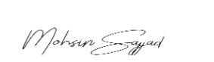

Student Signature: ______________

Submitted to:

Engr. Faheem Jan

Month Day, Year (11 05, 2025)

Department of Computer Systems Engineering

University of Engineering and Technology, Peshawar

**Generating a PWM Waveform**

TASKS:

1. Generate a signal of 500Hz with 40% duty cycle.

CODE:

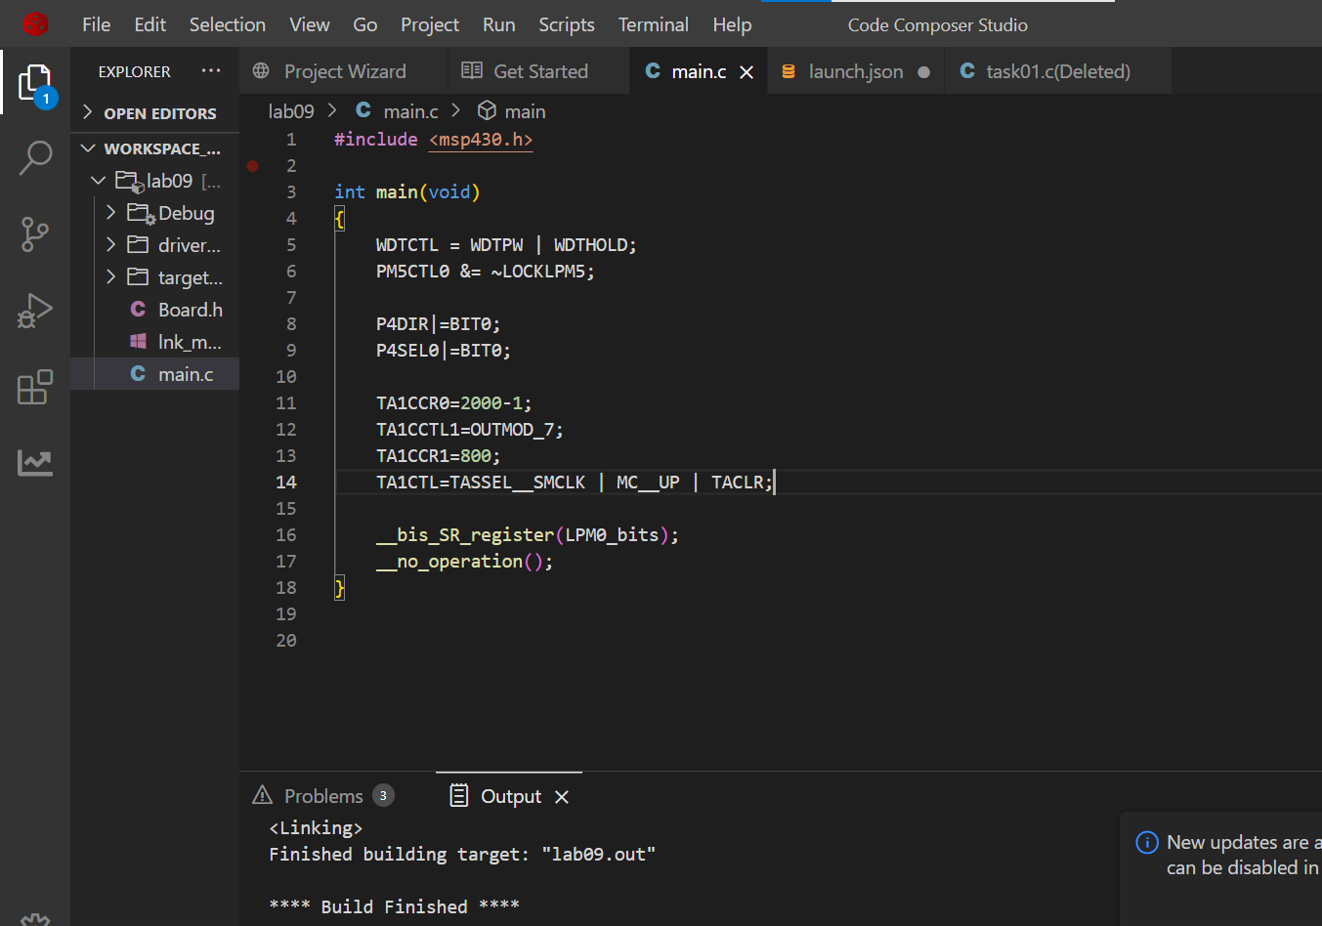

OUTPUT:

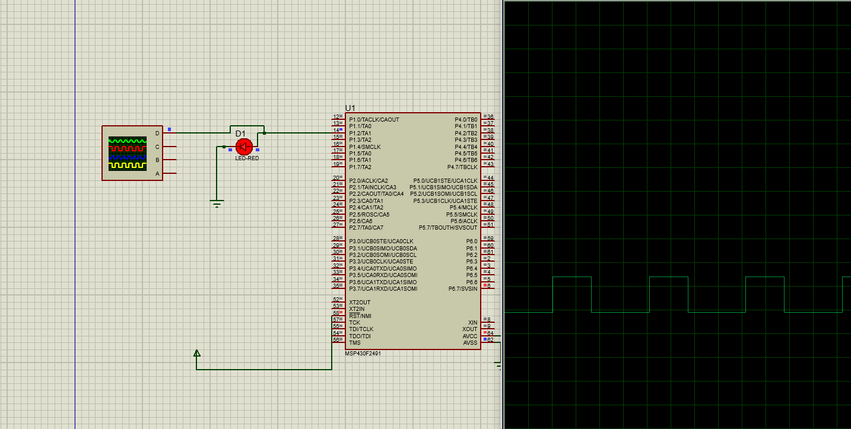

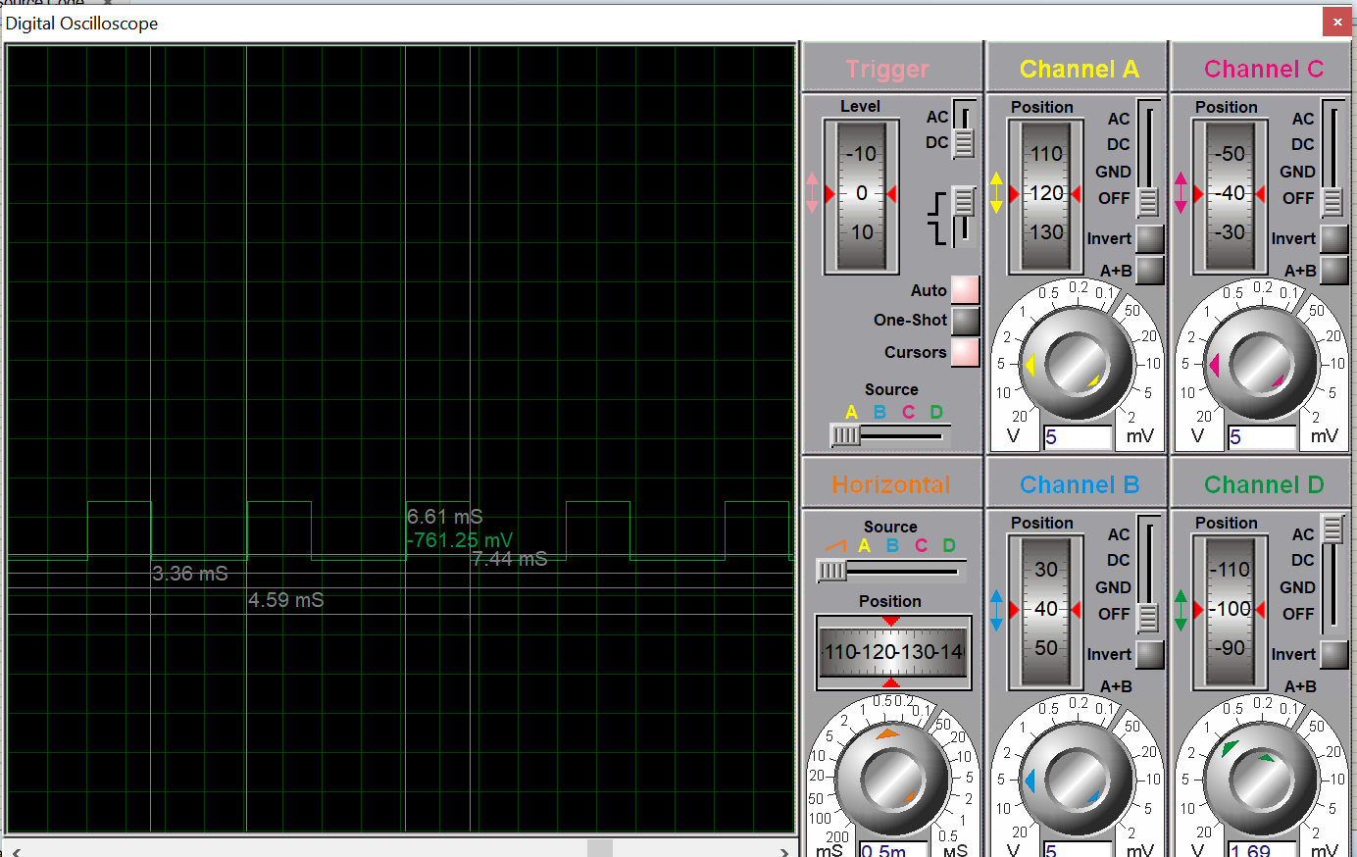

**Task 2:**

Generate a signal of 600Hz with 60% duty cycle on P1.3 Hint: use timer.

CODE:  
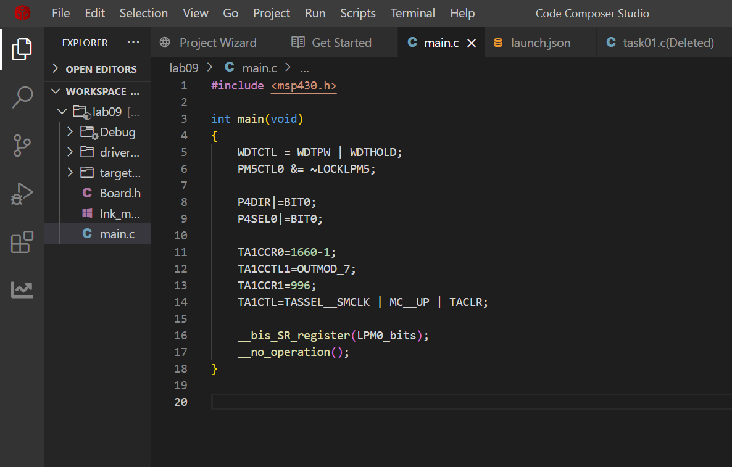

OUTPUT:  
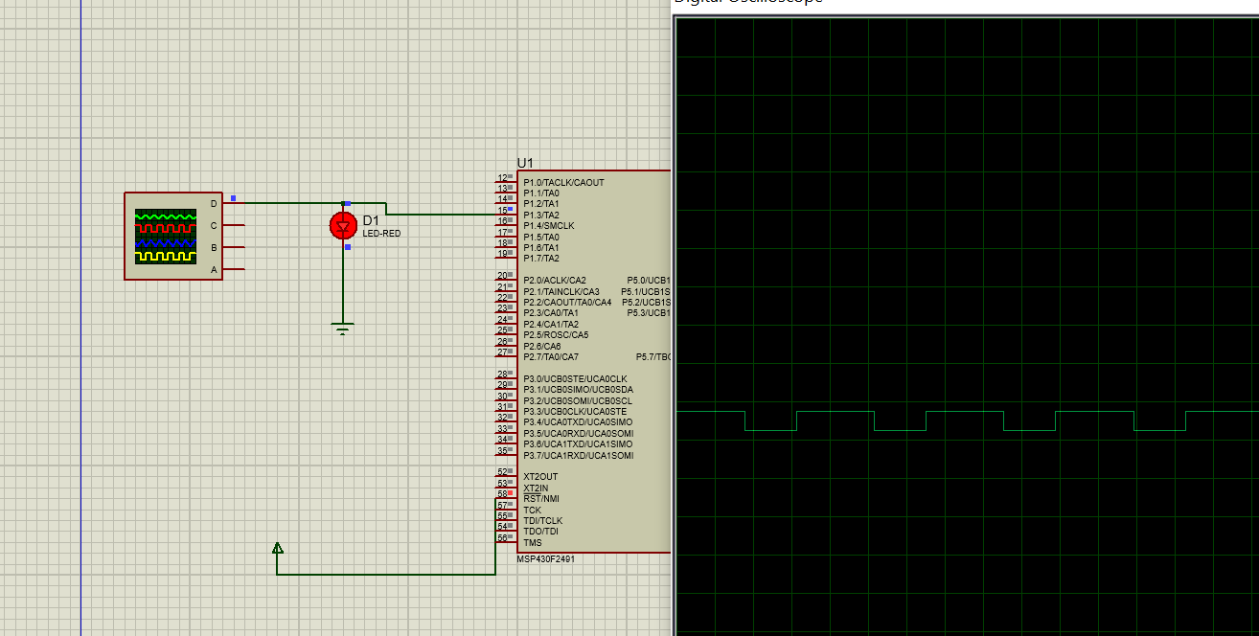

**TASK 03:**

Generate a signal of 100Hz with 40% duty cycle on P1.2 When a user presses a button at P2.3 the signal change to 300Hz with 60% duty cycle. Button pressed means Press and release.

CODE:

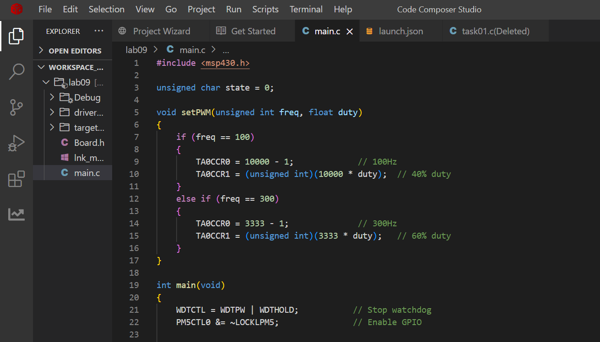

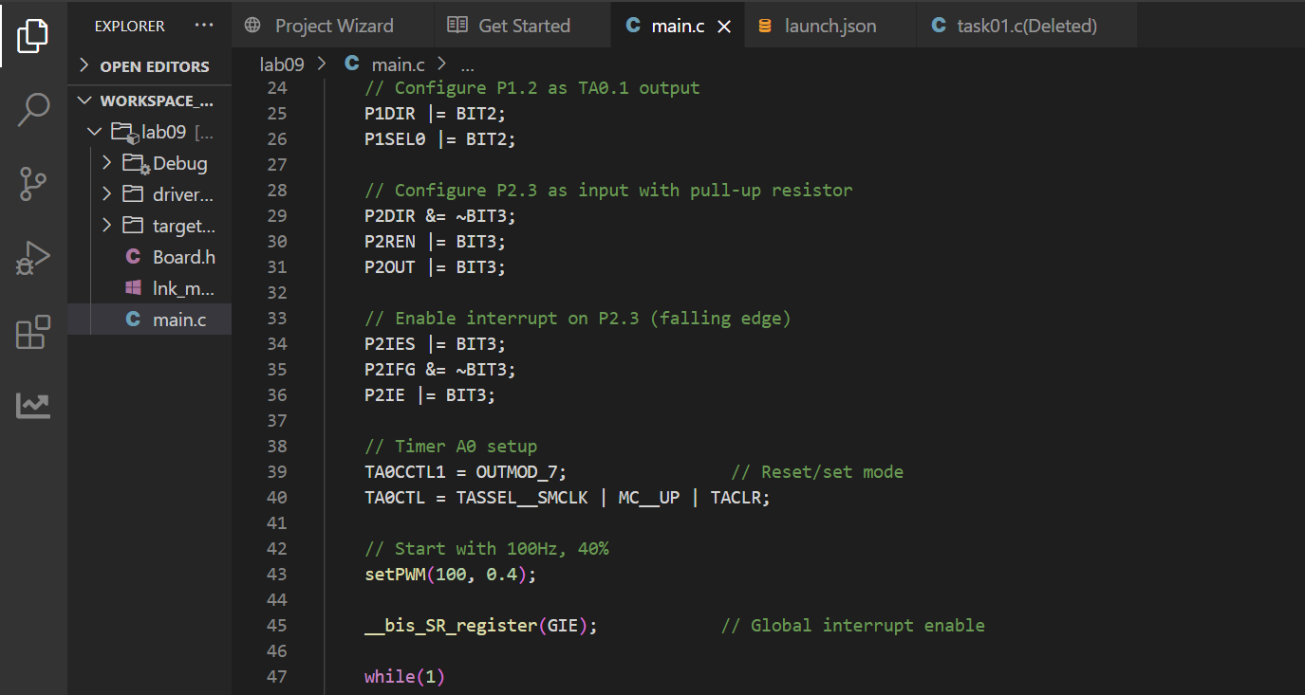

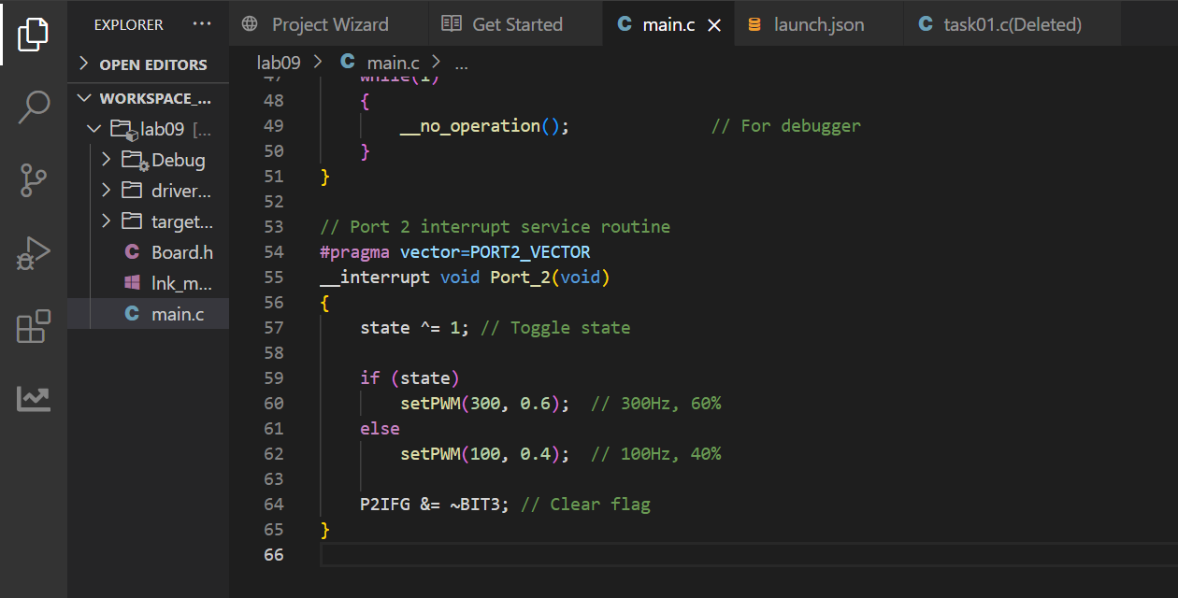

**OUTPUT:**

When button not pressed.

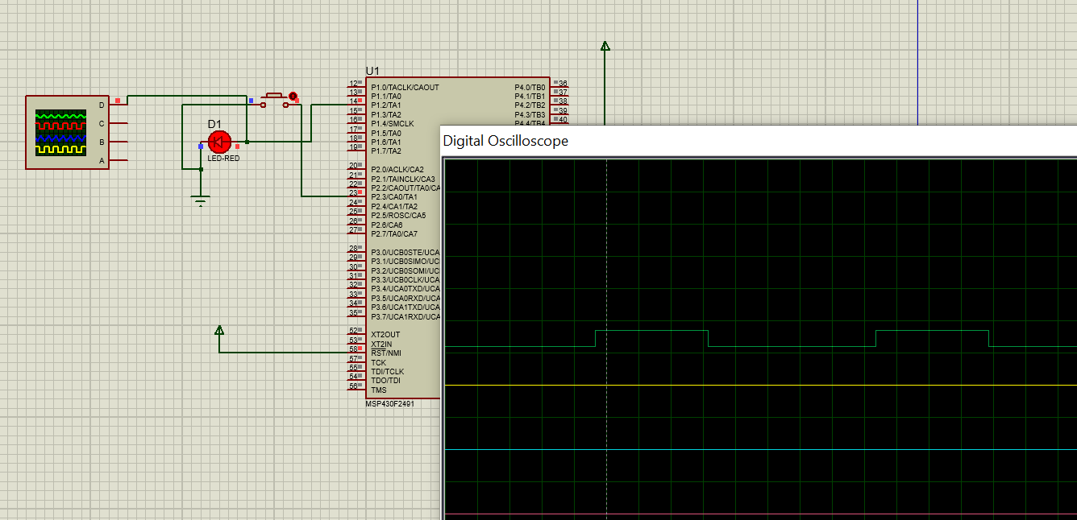

**When button pressed.**

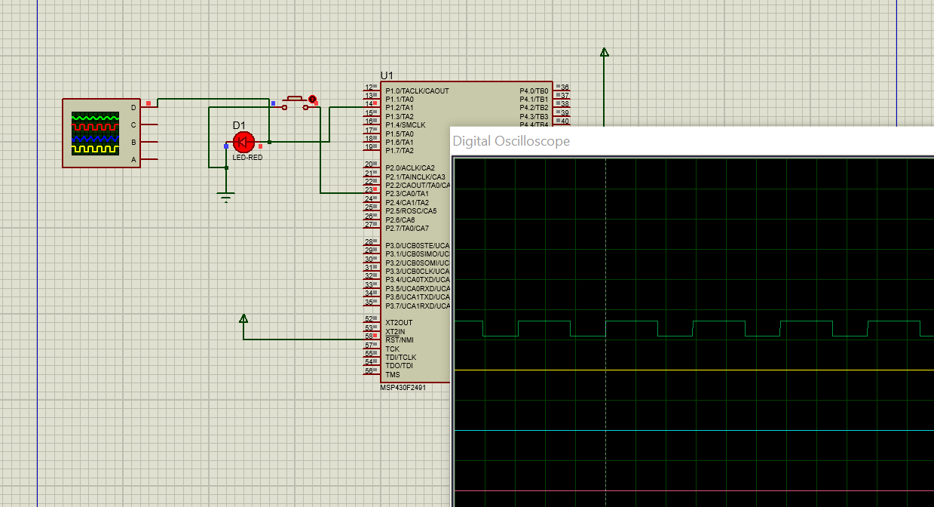

**Task 04:**  
This task consists of two parts, A. Generate a signal x of 2KHz with 75% duty cycle on P1.2. Similarly, generate another signal y of 1KHz with 25% duty cycle on P1.3. As soon a user presses a button on P2.1, x frequency drops by 100Hz and y increases by 100Hz. If x crosses y, an LED at P2.2 is turned ON. Use low power mode when nothing is happening. Additionally, use interrupts and not polling in your program. a. Use Timer interrupt for delay creation

**CODE:**  
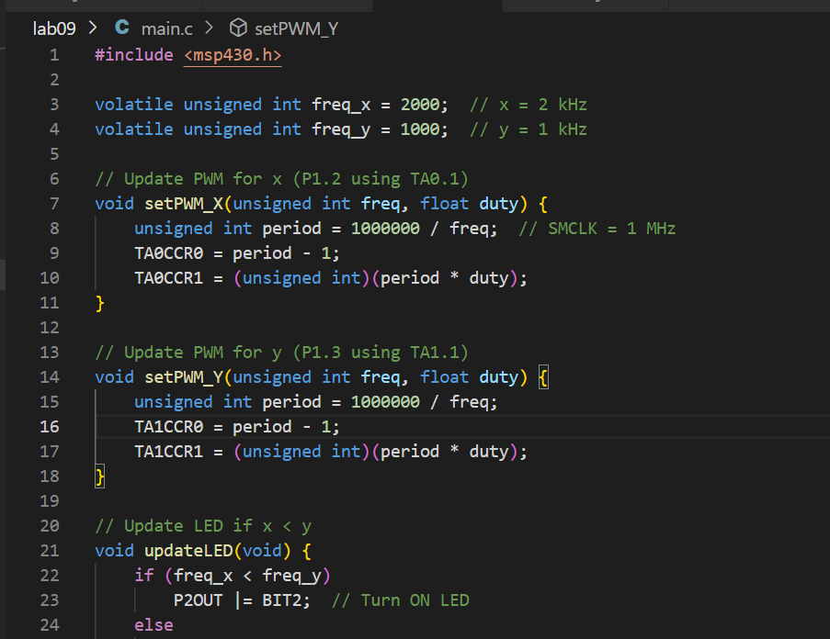

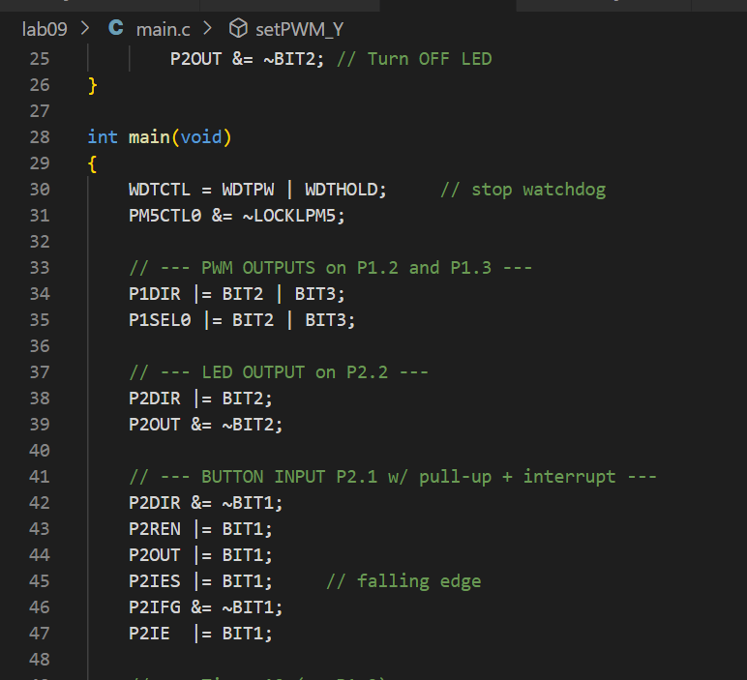

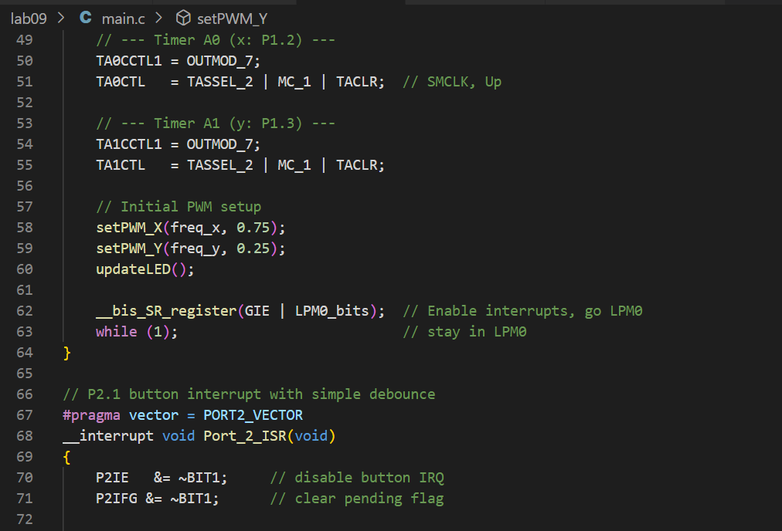

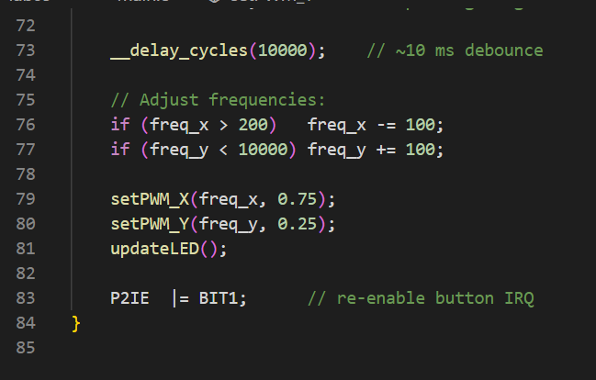

**Output:**

**Before crossing of x and y**

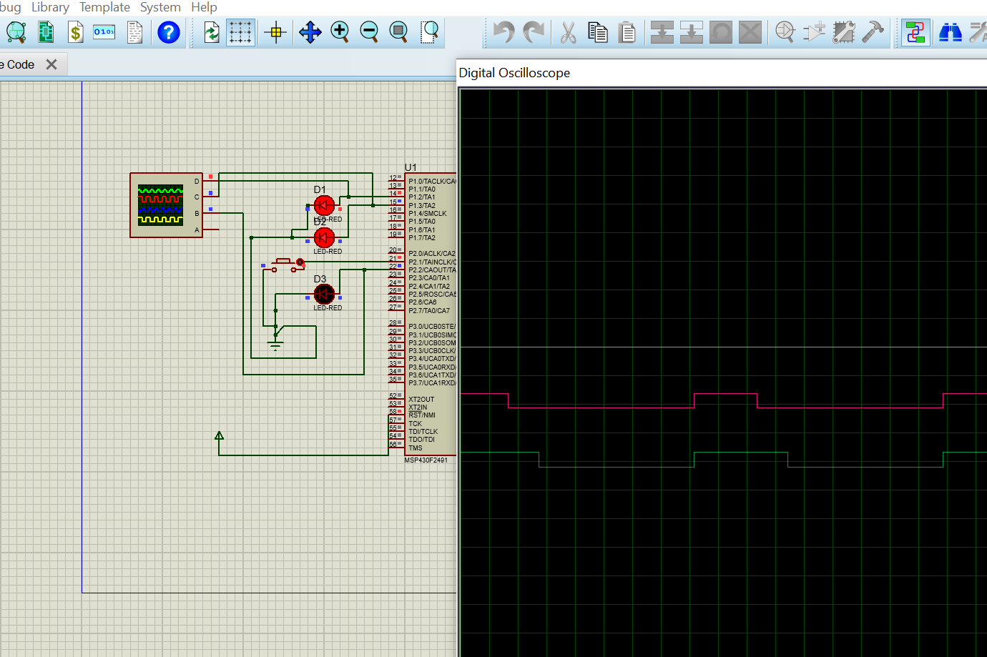

**After crossing of x and y**

